Wednesday 7th April 2021

Readings
Psalm 105.1-9
Luke 24.13-35

Reflection
You have two different ways of reflecting on this passage today. I suggest you choose one: either some questions to help you think about the Road to Emmaus and what God is saying to you through it or the Monologue by Nick Davis which Pam has kindly sent us.
Rebecca
Some thoughts on The Road to Emmaus

Cleopas and his unnamed companion had stayed in Jerusalem long enough to have heard the amazing news from the women that Jesus’ tomb was empty. Now they are making their way back to Emmaus and together trying to make sense of what they had seen and heard over the previous days.
Who are the people you talk to when you are trying to make sense of things you have seen or experienced?
Who are the people you talk to when you are trying to understand your faith?

Jesus comes alongside and joins them. They do not recognise him but begin to share their confusion and disappointment with him.; ‘but we had hoped that the as the one who was going to redeem Israel’ they say.
What are your disappointments?
In what ways has God not done as you had hoped? Be honest, are you disappointed with him in some ways?

Jesus begins to help them understand what has happened and uses the whole of scripture to show them how their hopes were not ill founded.
How does the Bible help you to understand who Jesus is and what he has done?
Are there parts of the Bible that you avoid reading? What might they be telling you about Jesus?

Cleopas and his friend urge Jesus to stay with them. Their offer of hospitality leads to a meal during which Jesus breaks bread, an act that enables them to recognise him. It may have been they recognised Jesus’ actions from his feeding the 5,000, or one of the many meals he ate or the Last Supper. Jesus then disappears.
When have the familiar actions of others enabled you to recognise Jesus at work in them?
How do you meet with Jesus in Holy Communion?

The two men ask each other ‘were not our hearts burning within us while he talked with us on the road and opened the Scriptures to us’. It is only in looking back with the knowledge that it was Jesus who was with them that they understand their experience.
Think of a time when it is only later that you have recognised that Jesus was with you in a situation?
Have you experienced that sense of the presence of the Holy Spirit when you are reading the Bible? How has it helped you?

The men immediately return to Jerusalem to tell the others what had happened. There they found that Jesus had appeared to others too.
Who is the Holy Spirit prompting you to speak with about Jesus and the difference he has made to your life?
How might sharing your experience of Jesus with other Christians help deepen your faith and understanding?

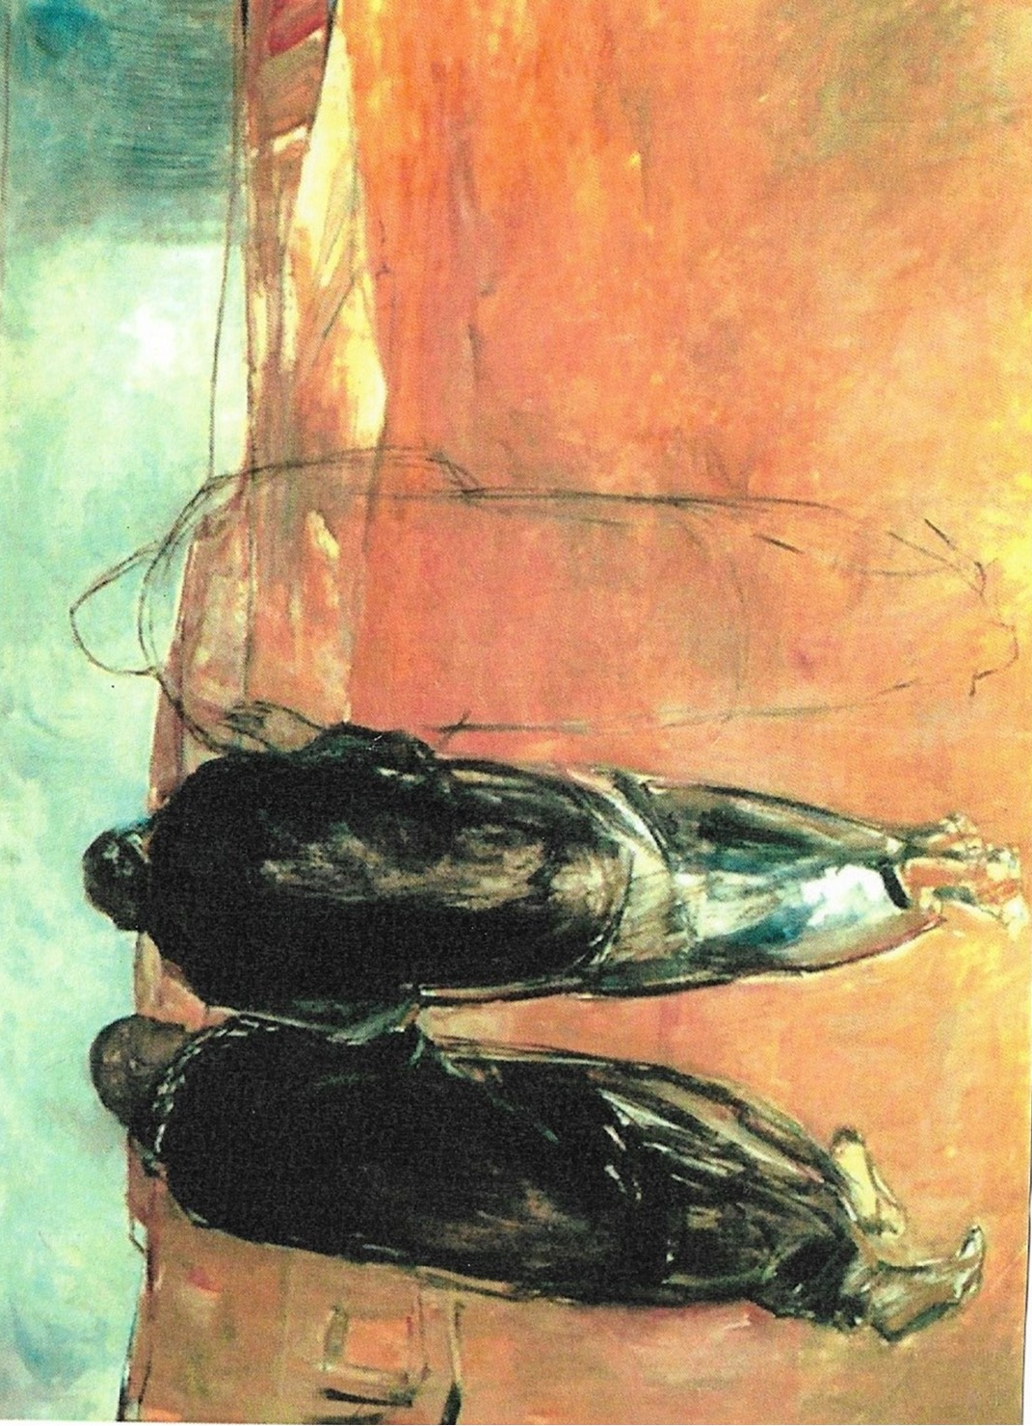

Emmaus Door (1992) by Janet Brooks-Gerloff

Dramatisation of The Road to Emmaus by Nick Davis

Cleopas and I left Jerusalem on the day after the Passover. There really didn’t
seem any point left in staying there. The place was crawling with Roman soldiers
and Temple guard, and the twelve who were closest to Jesus, or the eleven as
they now were, had barricaded themselves in the room where they had had the
Passover Meal, hoping that Pilate and Caiphas didn’t know where they were, they
were terrified. Oh and some of the women had got some strange stories: they’d
seen bands of angels, who’d told them that Jesus was alive.
Anyway, Cleopas had got a place at Emmaus, just up the road, so we slipped out
about an hour before noon, and set off for Emmaus. I was feeling really
depressed and down. I couldn’t get much lower. Cleopas was just angry. We
talked about what had been going on, well we didn’t really talk to each other, we
just sort of talked, though neither of us was listening. I was just sort of
grunting and Cleopas was getting really angry. Anyway, he’d got into his third
diatribe about what a cowardly prig Pilate was, when we noticed there was this
chap walking with us, and he said, “What are you talking about?” Cleopas, still in
anger mode, bit his head off; said, “What do you mean, what are we talking
about? You’ve been in Jerusalem, you must know what we have been talking
about. How can you not know, you stupid man!” I gave him the benefit of the
doubt, so I told him about Jesus, about the fact that we’d been with him for
three years, the fact that we’d hoped that he would be the one who would
actually free Judea again, and then what they’d done to him, and what had
happened and how depressed we felt. Oh, and I also chucked in the bit about
what the women had said, for good measure, ‘cos I thought he might give us a bit
of sympathy.
None of it. He called us stupid. He said we were slow of understanding. Then
he started rabbiting on about Moses, and the Prophets. I just turned off at
that point. But then I noticed that Cleopas was actually listening to him. So I
thought, well I’ll have a listen too, and, it was really amazing. He really knew his
scriptures. You know, he knew all the standard bits but he also knew all the bits
that I’d sort of ignored because I didn’t think the rabbis understood them
either. And, he went through the scriptures and, he pretty much put together a
biography of Jesus’ life, with bits from the scriptures. There were some bits I
knew like Moses had said there would be another prophet. We’d often wondered
well, maybe Jesus was that other prophet, but there were other bits, bits from
Ezekiel, Jeremiah, and particularly Isaiah, and as I listened, I got quite
emotional, I could feel my heart pounding within me. And then he got to the bit
in Isaiah about, “With his stripes we are healed” . . . and I thought about the
lashings that Jesus had had, and just after that, there’s a bit where he says:

“God has laid on him the sin of us all”. I could feel my eyes pricking, so I
pretended I’d got sand in my face.
Anyway, we got to Emmaus, and Cleopas said, would you like to join us for a meal,
maybe stay the night if he wasn’t in a hurry, so he said, “OK”. Cleopas went off
to a neighbour to beg some bread and fish, and I scratched around and managed
to find some wine. And we were just settling down to this meal when this guy
leans over to the middle of the table and picks up the loaf of bread in both
hands, gives thanks, and blesses the bread and starts to break it. Well it only
takes a couple of seconds to break a loaf of bread, but it seemed to take an age
because it was as if the world stood still. ‘Cos I’d only ever seen one person
break bread that way before. And that was the Master. I looked over to
Cleopas, his jaw had dropped and was almost on the floor. He looked back at me
and, we didn’t need to say anything to each other, we just knew. This was the
Master. We looked back to where he was, but he’d disappeared. Gone. There
was just the loaf of bread, broken in two, lying on the table next to the cup of
wine.
Well we couldn’t stay there any longer, we had to get back to tell the others. So
we stuffed the bread and the fish in a bag and dashed off back to Jerusalem as
quickly as we could. Just got back in through the East gate before dusk, went
and hammered on the door of the Upper Room until the 11 let us in, and we burst
in and we spilled out our story to them. I don’t remember much about the rest
of that night, we were just so deliriously happy.
Anyway, that was many years ago now. Thank you for letting me share that
story with you. I love telling it because it reminds me for one thing of all those
scriptures that tell us who the Master was, and what he did, but most of all, it
reminds me that I, along with Cleopas of course, was the first to break bread
with my risen Lord.

Collect

God of glory, by the raising of your Son
you have broken the chains of death and hell:
fill your Church with faith and hope;
for a new day has dawned and the way to life stands open
in our Saviour Jesus Christ. Amen.

Prayers

You might like to include some of these things in your prayers:

Give thanks:
- for the death and resurrection of Jesus
- for the gifts of God’s word and Holy Communion and the ways they reveal more of Jesus to us
- for those who help us grow in our faith

Pray for those:
- who are disappointed
- who are struggling in their faith
- who are tired and weary

Pray for:
- the life and witness of Christ’s Church, particularly his Church at Sunnyside and St John’s
- all who share the good news of Jesus in Berkhamsted and further a field
- for all involved in translating and disseminating the Bible

